# Account Maintenance

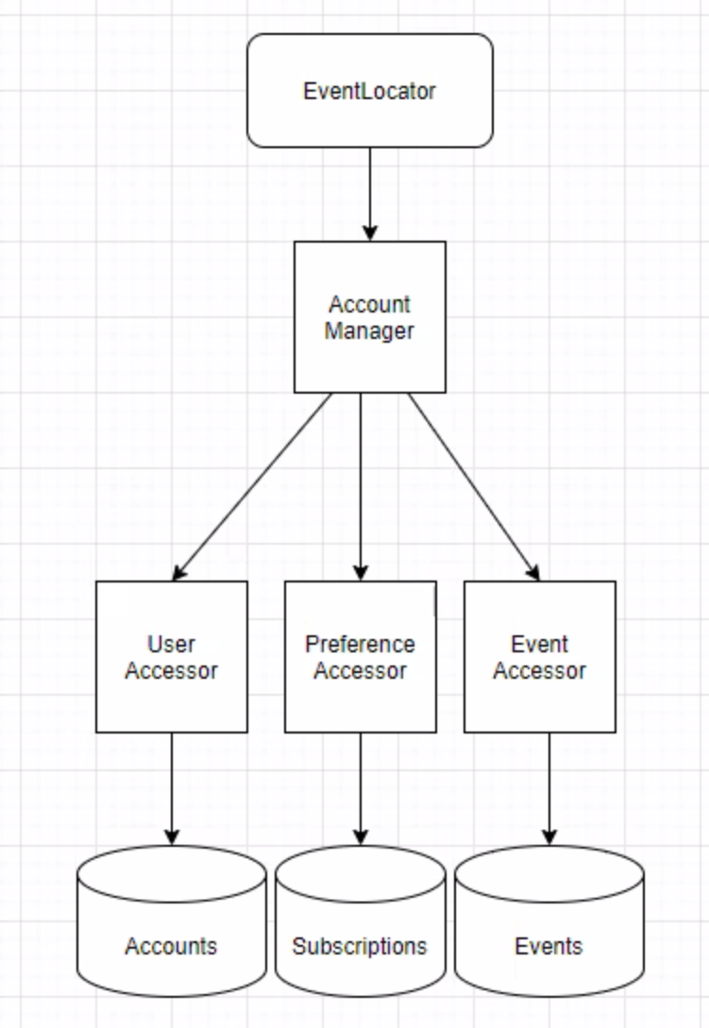

## Component Roles

* Account Manager
  + Determines user roll (anonymous or registered), manages method calls to user and preference accessors.
* User Accessor
  + Interacts with account database.
* Preference Accessor
  + Interacts with preferences database.
* Event Accessor
  + Interacts with events database.

## Use Case Sequence

1. Register Account
2. Log In
3. Update Account
4. Delete Account
5. Retrieve List of Events
6. Add/Update Preferences
7. Find Preferences
8. Remove Preferences

## Services

### Account Manager

#### IEventLocatorAccountManager.CreateAccount

|  |  |
| --- | --- |
| Description |  |
| Pre-conditions | Email address and valid password provided |
| Post-conditions | User account is created in database |
| Parameters | [Parameter 1 UserAccount UserObject] |

*IEventLocatorAccountManager.UpdateAccount*

|  |  |
| --- | --- |
| Description |  |
| Pre-conditions | 1. User must be logged in  2. Valid UserAccount must be available  3. User has updated Account information |
| Post-conditions | User account is updated in database |
| Parameters | [Parameter 1 UserAccount UserObject] |

*IEventLocatorAccountManager.DeleteAccount*

|  |  |
| --- | --- |
| Description |  |
| Pre-conditions | User must be logged in |
| Post-conditions | User account is removed from database |
| Parameters | [Parameter 1 Account ID, Int] |

*IEventLocatorAccountManager.LogIn*

|  |  |
| --- | --- |
| Description |  |
| Pre-conditions | Valid email and password provided |
| Post-conditions | User is validated and UserAccount is passed back |
| Parameters | [Parameter 1 EmailAddress, String]  [Parameter 2 Password, String] |

## DTO Definition

|  |  |
| --- | --- |
| UserAccountDTO | [Account ID, Int]  [Email Address, String]  [First Name, String]  [Last Name, String]  [Phone Number, String]  [Password, String] |
|  |  |

*IEventLocatorAccountManager.*

|  |  |
| --- | --- |
| Description |  |
| Pre-conditions | Valid email and password provided |
| Post-conditions | User is validated and UserAccount is passed back |
| Parameters | [Parameter 1 EmailAddress, String]  [Parameter 2 Password, String] |

## DTO Definition

|  |  |
| --- | --- |
| UserSubscriptionsDTO | [AccountID, Int]  [SubscriptionID, Int]  [EventID, Int] |
|  |  |

*IEventLocatorAccountManager.GetEvents*

|  |  |
| --- | --- |
| Description |  |
| Pre-conditions | Valid Date Range provided (in future) |
| Post-conditions | A list of Events within the date range will be returned. |
| Parameters | [Parameter 1 BeginDate, Date]  [Parameter 2 EndDate, Date] |

## DTO Definition

|  |  |
| --- | --- |
| EventDTO | [EventID, Int]  [EventName, String]  [EventLocation, AddressObject]  [EventDate, Date] |
|  |  |